Table of Contents

**Acknowledgement**

|  |  |  |
| --- | --- | --- |
| **Sl.no** | **Chapter Title** | **Page Number** |
| 1 | Introduction | 5 |
| 2 | Table description | 6-8 |
| 3 | Design | 9-12 |
| 4 | Hardware and software requirements | 13-15 |
| 5 | Code snippets and screenshots | 16-22 |
| 6 | Conclusion | 23 |
|  |  |  |

**Future enhancement**

**References**

**Chapter-1**

**INTRODUCTION TO PROJECT**

**1.1 BRIEF DESCRIPTION**

The mini project "PHARMACY MANAGEMENT SYSTEM" is created as part of the fifth semester DBMS laboratory to fulfil a requirement for the BE (Information Science) course.

**1.2 PROJECT DESCRIPTION**

The Pharmacy Management System project was created for an established medical store in the city. This project is being developed to manage all operations at the medical store. It will include the entire basic module for managing the operations of the medical store.

**1.3 OBJECTIVES**

The application's main goal is to automate the seller's existing system of manually maintained records of counter sales, purchases, reorder levels, Supplier and Customer monetary positions, and other related transactions.

**1.4 SCOPE**

Any other retailer can use this application to automate the manual operation of keeping records related to the topic of managing the stock and liquid flows.

**Chapter-2**

## TABLE DESCRIPTION

### 2.1.1ADMIN

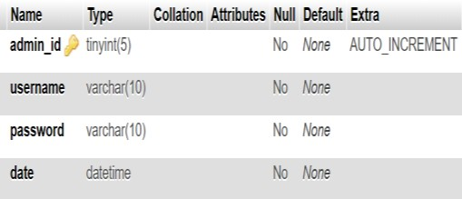ADMIN table has the admin_id, admin_username, admin_password and admin_id is used as the primary key.

## 2.1.2PHARMACIST

PHARMACIST table has the attributes pharmacist_id,first_name, last_name,staff_id,postal_address,phone,email,username,password,

date and pharmacist_id is the primary keys .

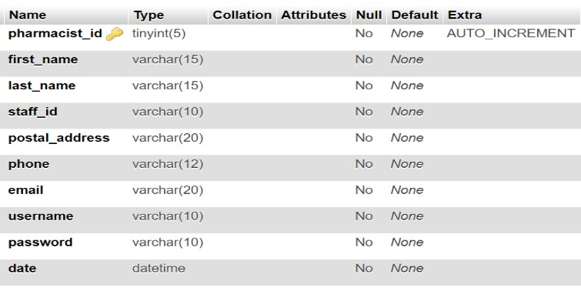

**Table 2.1.2 Structure of PHARMACIST**

## 2.1.3 PRESCRIPTION

PRESCRIPTION table has attributesid,prescription_id,customer_id

customer_name, invoice_id,phone,date and pharmacist_id and id is the primary keys .

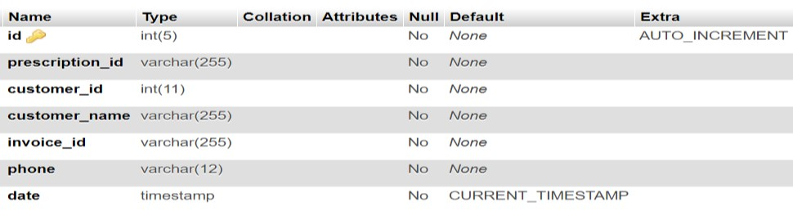

**Table 2.1.3 Structure of PRESCRIPTION**

## 2.1.4 SALES

SALES table has attributes userid,invoice,drug,cost,quantity,day,

month,year and userid is the primary keys .

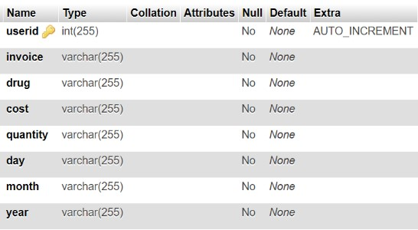

**Table 2.1.4 Structure of SALES**

## 2.1.5 STOCK

STOCK table has attributes stock_id,drug_name,category,description,

company, supplier and strength,quantity,cost,status,date_supplied and stock_id is the primary keys .

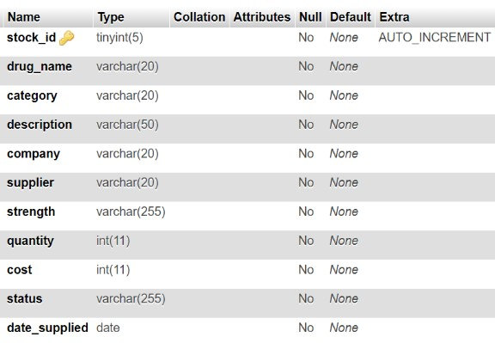

**Table 2.10 Structure of STOCK**

## 2.3.11 TEMPPRESCRI

TEMPPRISCRI table has the attributes userid, customer_id,

customer_name,phone, drug_name,strength,dose,quantity and stock_id is the primary keys .

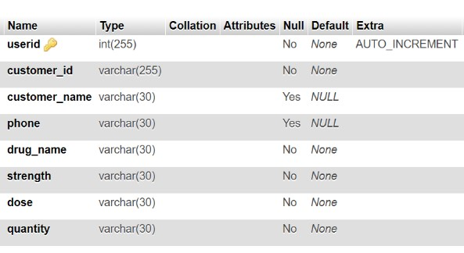

**Table 2.11 Structure of TEMPPRESCRI**

**Chapter-3**

**DESIGN**

**3.1 ENTITY RELATIONSHIP DIAGRAM:**

The ER Relationship Model, which is frequently used to create an initial database architecture, enables us to represent the data involved in a real-world company in terms of objects and their relationship. It is significant largely for the database design.

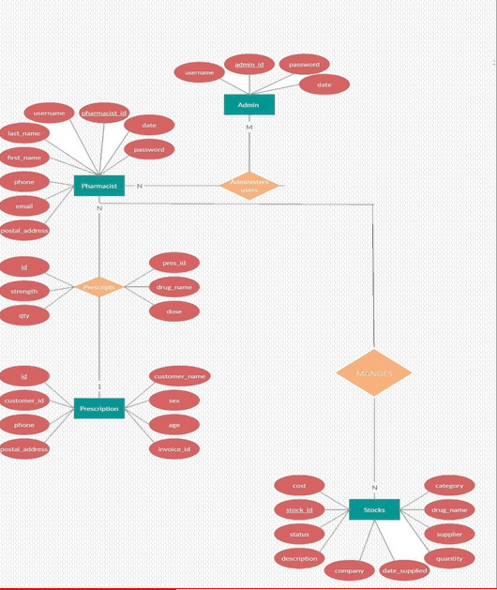

In this ER Diagram shown in

Fig 3.1 Entities

* ADMIN
* PHARMACIST
* PRESCRIPTS
* PRESCRIPTION
* STOCK

are represented by rectangles, attributes of the tables are represented by ovals and relationships are represented using diamonds

## 3.2 SCHEMA DIAGRAM

A visual diagram that depicts the database objects and their relationships, as well as how the interactions between them are depicted, can be used to portray a database. 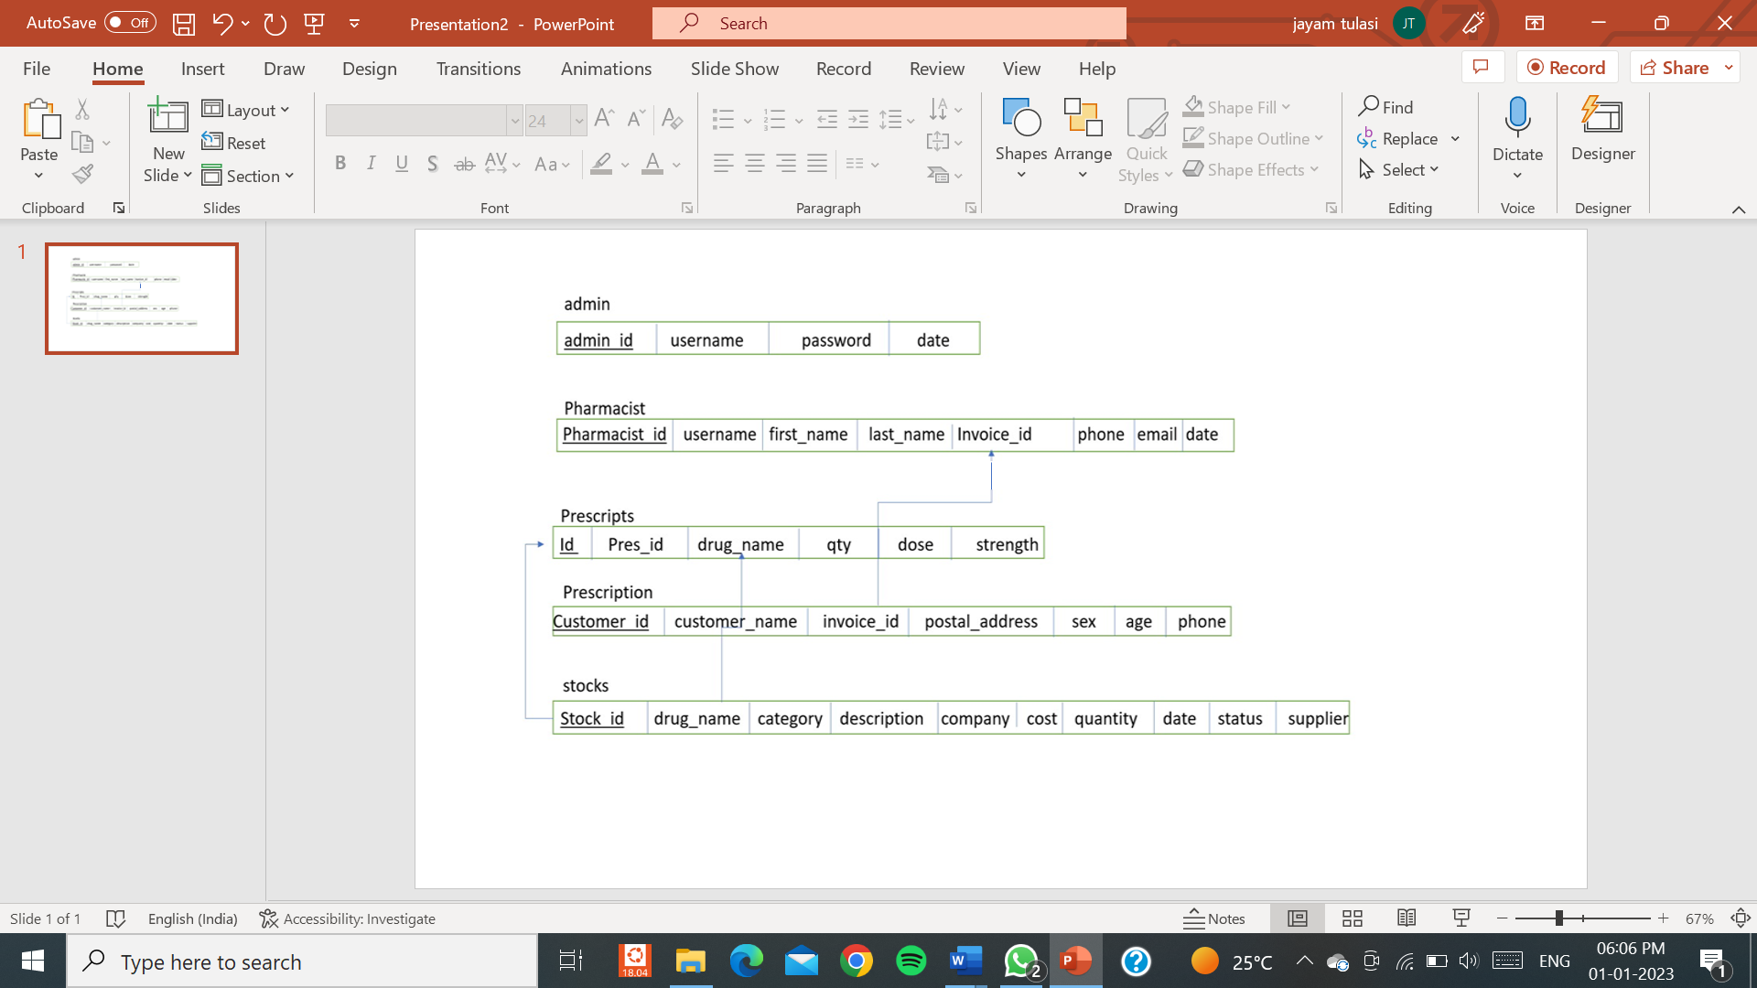

This Schema Diagram represents different tables used and underlined attributes are primary keys and arrows are used to represent foreign keys.

**Chapter-4**

**HARDWARE AND SOFTWARE REQUIREMENTS**

### 4.1 HARDWARE REQUIREMENTS

* A desktop or laptop with a proper internet connection.
* 20 GB of hard disk (free space)
* Minimum 2GB or Greater of the RAM
* Windows 7 or 8 or 10 Operating system.

### 4.2 SOFTWARE REQUIREMENTS

#### 4.2.1 SERVER SIDE

1. Programming language: PHP 5.6.31
2. Web Server: Apache 2.4.27
3. Database: SQL 5.7.19

#### 4.2.2 CLIENT SIDE

1. Programming language: JAVASCRIPT, HTML, CSS
2. OS: windows7/8/10
3. MYSQL server

##### 4.2.1.1 PHP

PHP is a server-side scripting language used for general programming as well as for the building of websites. PHP code can be used alone, in conjunction with different web template systems, web content management systems, and web frameworks, or it can be incorporated into HTML or HTML5 markup. A PHP interpreter that is implemented as a module in the web server typically processes PHP code. The outputs of the interpreted and executed PHP code, which could be any kind of data, including graphics, are combined with the created webpage by the web server software.

##### 4.2.1.2 WEB SERVER: APACHE

The most popular web server software is Apache. Apache is open-source software that is offered for free and is created and maintained by the Apache Software Foundation. On 67% of all web servers in use today, it is active. It is quick, trustworthy, and secure. By utilising extensions and modules, it can be highly customised to match the requirements of numerous diverse contexts. The majority of WordPress hosting companies use the Apache web server. WordPress can, however, also function on other web server applications.

##### 4.2.1.3 HTML

Hyper Text Markup Language (HTML) is the abbreviation for this language.

Simply said, "Text within Text" is what is meant by hypertext. A text that contains links is a hypertext. You have clicked on a hypertext each time you click on a word that directs you to a different webpage.

Markup language: Text can be made more interactive and dynamic by using a markup language, which is a computer language. It may transform a text into graphics, tables, links, and more. Numerous HTML tags make up an HTML document, and each HTML tag has a unique content.

**4.2.1.4 JAVA SCRIPT**

Java script is a dynamic computer programming language. It is most frequently utilised as a part of web pages because of how client-side script can interact with users and build dynamic pages thanks to its implementations. It is an interpretable object-oriented programming language.

**Chapter-5**

**CODE SNIPPETS AND SCREENSHOTS**

**5.1 CODESNIPPETS**

## 5.1.1 DATABASE CONNECTION

The connect() / mysqli_connect() function opens a new connection to the MySQL server with the following syntax:

mysqli_connect(host, username, password, dbname);

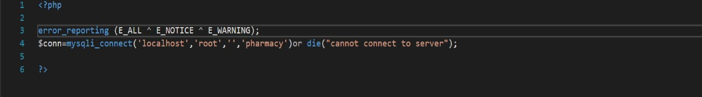

**5.1.1 Database Connection**

## 5.1.2 INPUT QUERY

This query is used to get the details of the cashier using INSERT query.

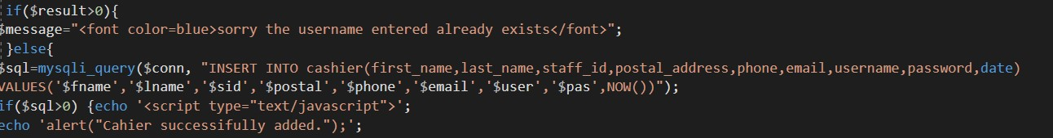

**5.1.2 Input Query**

**5.1.3 SELECT QUERY**

In this query, all the details are fetched using SELECT * command

]

**5.3 Select Query**

## 5.1.4 UPDATE QUERY

Here the update query is called to update the user of an already existing based on its name and category id, address etc respectively.

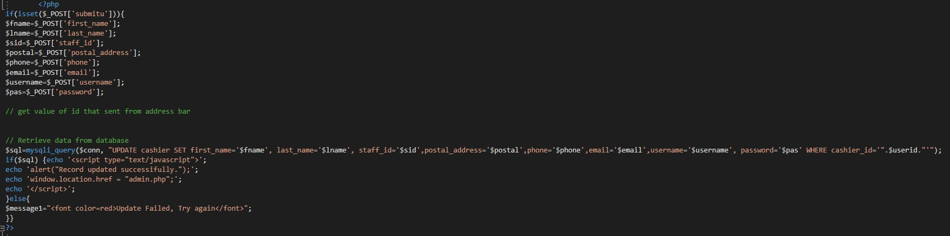

**5.1.4 Update Query**

**5.1.5 DELETE QUERY**

Here the delete query is called to delete a particular person based on user id, user name



**5.1.5 Delete Query**

**5.2 SCREENSHOTS**

## 5.2.1 LOGIN PAGE

This is the first window when the application is executed.

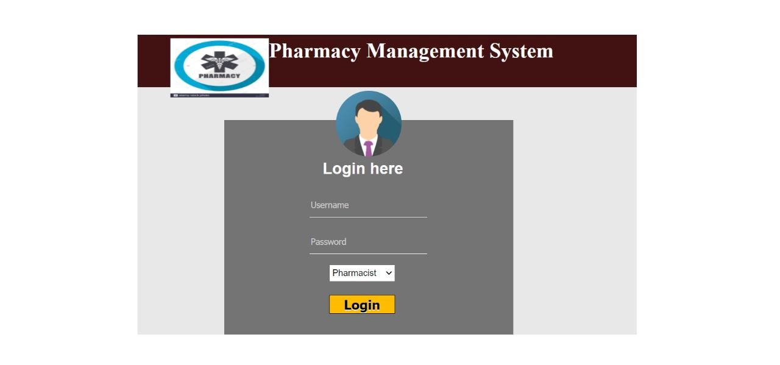

**5.2.1 LOGIN Page**

## 5.2.2 ADMIN HOME PAGE

On successful login, admin can either add, update or delete any user and can also view the details of all the pharmacists

**5.2.2 Admin Login Page**

## 5.2.3 ADMIN_PHARMACIST PAGE

admin can access to add, update or delete any pharmacist and view their id,username,firstname and lastname .

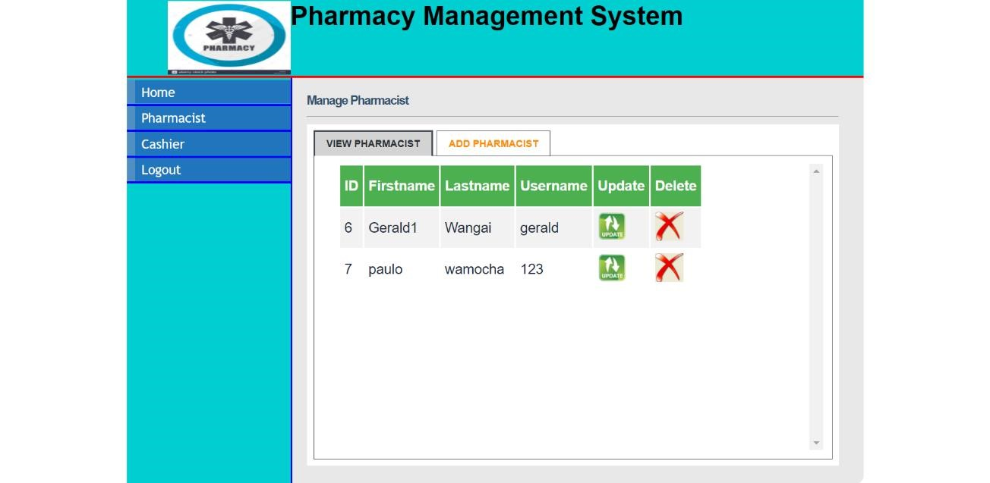 **5.2.3 Admin_Pharmacist Page**

## 5.2.4 PHARMACIST HOME PAGE

PHARMACIST can view and write prescription and also check the availability of medicine stock.

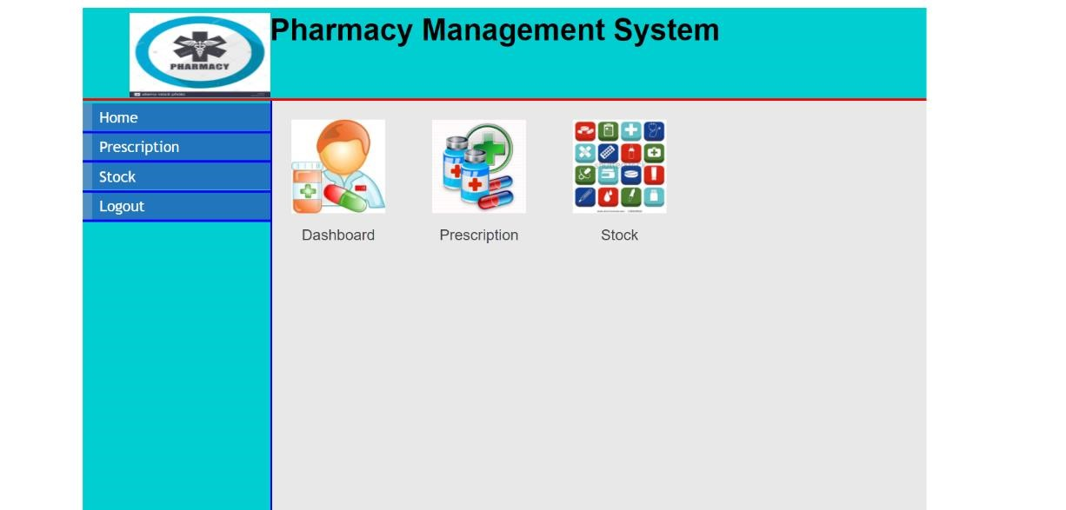

**5.2.4 PHARMACIST Home Page**

## 5.2.5 PHARMACIST_PRESCRIPTION PAGE

On this page, PHARMACIST can view and add the prescription ,here the invoice id will generate .

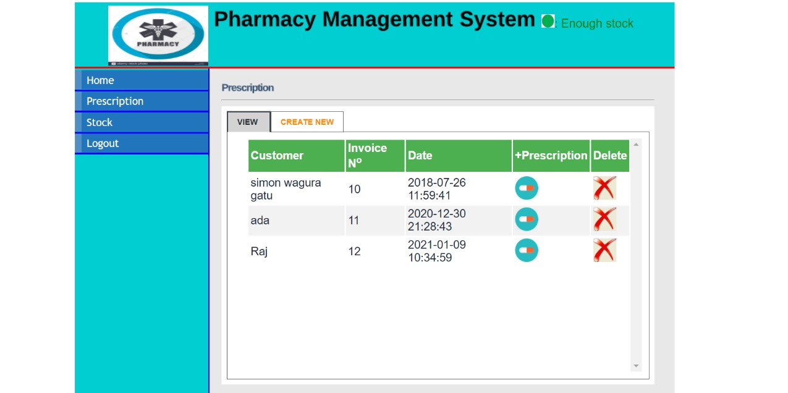 **5.2.5 Pharmacist Prescription Page**

## 5.2.6 PHARMACIST STOCK PAGE

On this page, Pharmacist can view the name of drugs,availability of stocks,description of drugs,availability and access to remove medicine

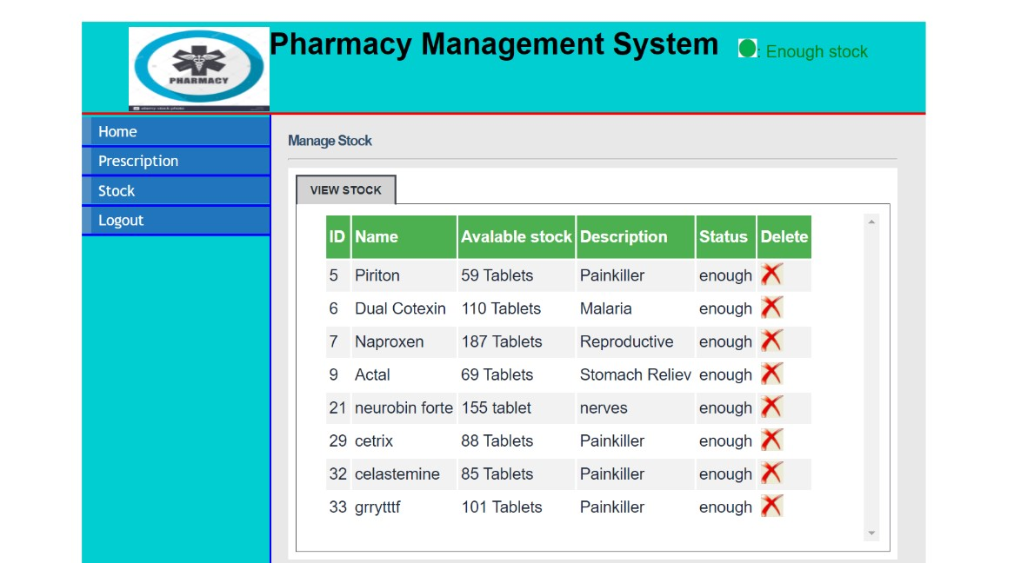

**5.2.6 PHARMACIST STOCK PAGE**

**Chapter-6**

**CONCLUSION**

# A pharmacy management system is really a piece of software that manages and stores important data regarding a pharmacy's management database. This software aids in the efficient operation of a pharmacy or shop. It provides data that may be updated and modified concerning medications or other drugs that are now in stock. It functions in accordance with the user's needs and offers alternatives in that regard. It allows users to enter manufacturing information as well as the date when medicines go off-patent when they are placed in stock and for sales transactions. This software also has the ability to print bills, invoices, and other documents. It also allows for the storage of supplier supply records. Additionally, there are other features accessible.

# FUTURE ENHANCEMENT

Due to the findings from carrying out this research on Pharmacy Management System, some points to consider in its implementation in the future include:

1. A platform capable of use at a regional/national level

2.Strict security measures put in place to prevent an abuse of the application in general

**REFERENCES**

1. <http://php.net/>
2. https://www.<http://en.wikipedia.org/wiki/PHP>
3. https://www.w3shools.com

Done by:

Busetty Lasya-322010329001

Pinnamreddy Jagan Satwik -322010328021

Thotamsetty surya-322010328025